# Use of wood with Designs

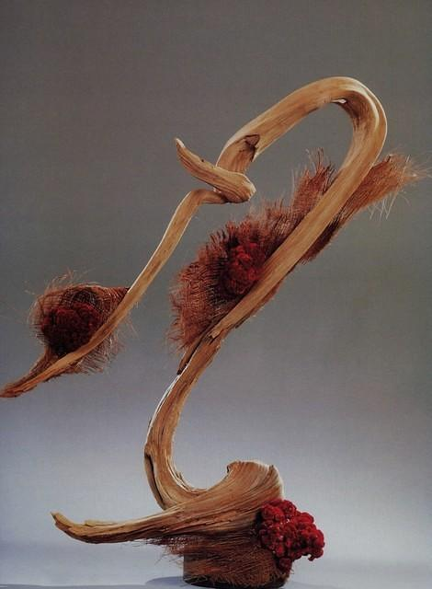

**"Forward Motion"**

Driftwood (cedar), Coconut sheeves, celosia.

<http://gloriafreitas.com/gallery/index.php/Flower-Arrangements/Forward-Motion>

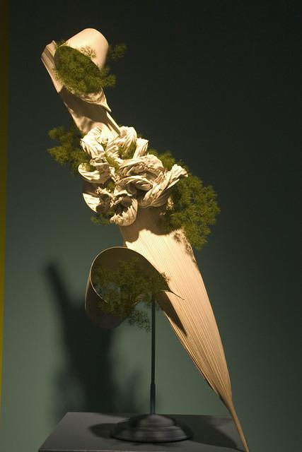

**Boston FlowerShow "Ski Jump"**

....palm spathe, ming fern painted white to represent snow. The ming fern represents a "spill" on the slope

<http://gloriafreitas.com/gallery/index.php/Flower-Arrangements/07Mar_FlowerShow_030>

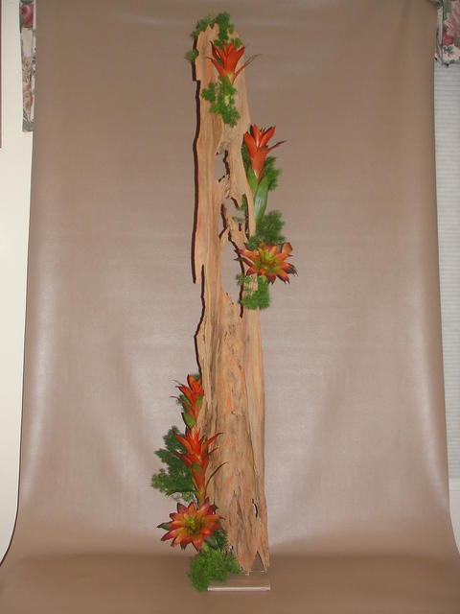

**"Fire and Smoke" Tribute to Firefighters**

Pecky cyprus wood, bromilias, ming fern....5' tall

# Dried material – kinetic to show something different

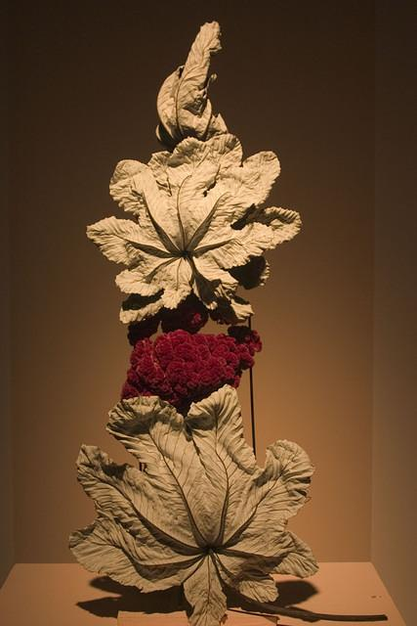

**Mar FlowerShow "I am a Magician"**

This motorized design (see next photo with it open) opens and closes. The mechanisn was taken out of a Halloween toy.

http://gloriafreitas.com/gallery/index.php/Flower-Arrangements/07Mar_FlowerShow_023

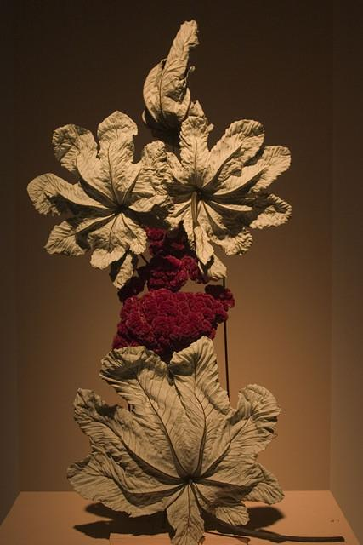

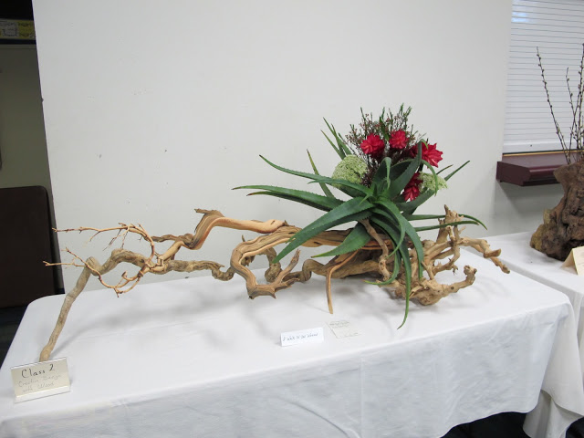

Class 2:  Creative Wood Design:  1st Place:  Camille Van Ast ﻿  
Designer Choice Award

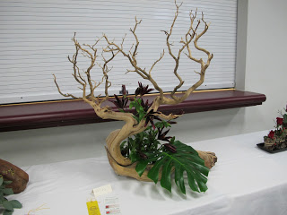

Class 2:  Creative Design with Wood:  3rd Place:  Beverly Switzer

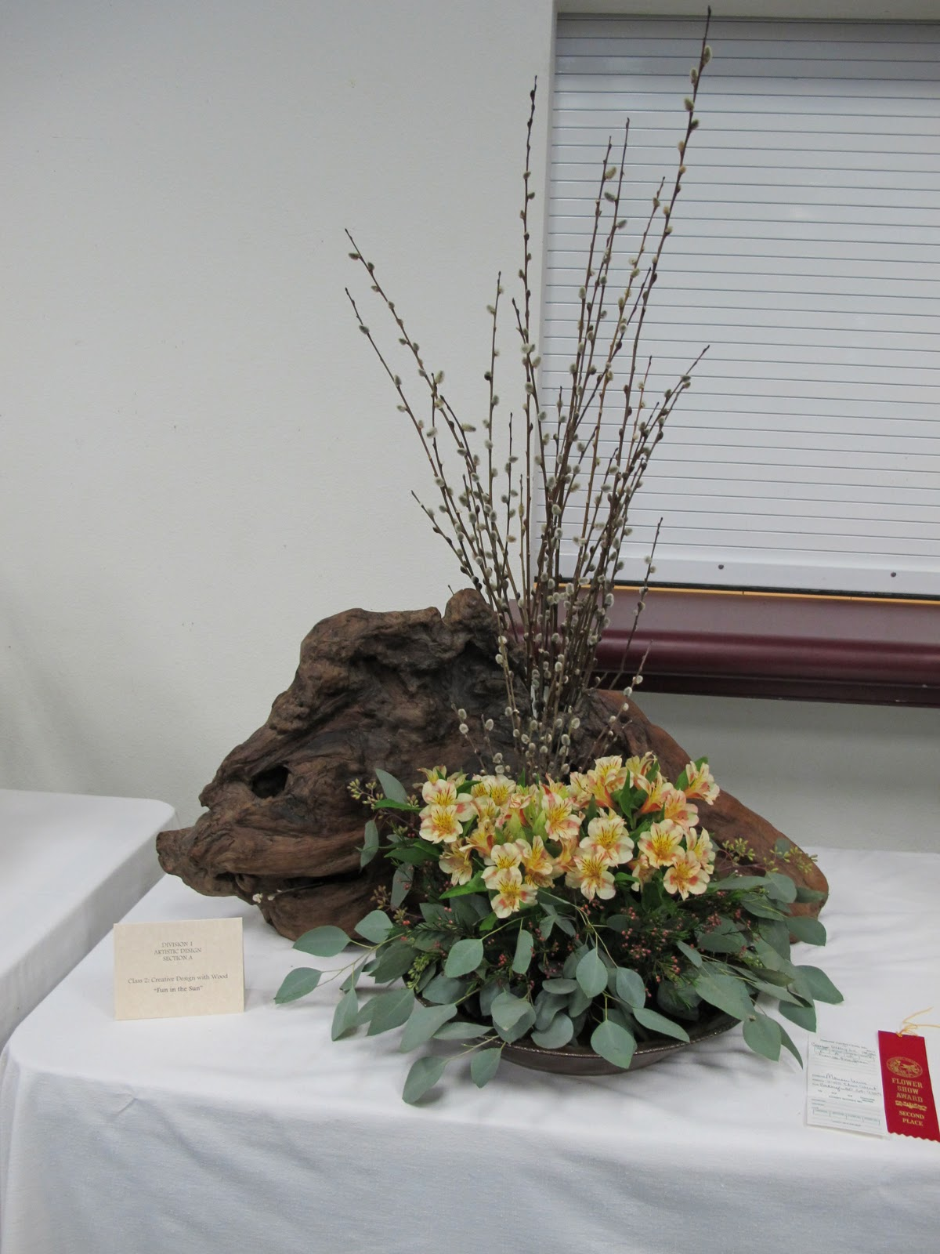

Class 2:  Creative Design with Wood:  2nd Place Monica Lewis